Name | Class: 2T

CATHOLIC JUNIOR COLLEGE

CHEMISTRY 8872/02
Higher 1

Paper 2
JC 2 Preliminary Examinations
13th September 2010

2 hours

Candidates answer Section A on Question Paper.
Additional Materials: Writing Paper
Graph Paper
Data Booklet

READ THESE INSTRUCTIONS FIRST

Write your name and class on all the work you hand in.
Write in dark blue or black pen on both sides of the paper.
You may use a soft pencil for any diagrams, graphs or rough working.
Do not use paper clips, highlighters, glue or correction fluid.

Section A
Answer all questions.

Section B
Answer two questions on separate answer paper.
Circle their numbers in the box provided below.

At the end of the examinations, fasten all your work securely together.
The number of marks is given in brackets [ ] at the end of each question or part question.
For Examiner’s Use
Paper 1
Paper 2 | Section A
Paper 2 | Q5
Paper 2 | Q6
Paper 2 | Q7
Total

There are a total of 11 printed pages and 1 blank page.
Section A
Answer all questions in this section.

- (a) When arsenic was reacted with nitric acid, HNO₃, arsenic(V) acid, H₃AsO₄ and NO₂ were produced. Potassium iodide, KI was added to the resulting mixture and a brown solution, X was observed to form and arsenic(V) acid was also converted to H₂AsO₃.
Given that the half equations for the first and second reactions arsenic are:
As + 4 H₂O ⇌ AsO₄³⁻ + 8 H⁺ + 5 e⁻ --- 1st reaction
AsO₄³⁻+ 2 H⁺ + e⁻ ⇌ AsO₃²⁻+ H₂O --- 2nd reaction

(i) State the identity of the brown solution, X that was formed.
Brown solution is iodine, I₂.
…………………………………………………………………………………………………

(ii) With the use of the equations given and the Data Booklet, write down the two balanced ionic equations for the reactions above.
1st reaction: As + 4 H₂O ⇌ AsO₄³⁻ + 8 H⁺ + 5 e⁻
5 ( NO₃⁻ + 2 H⁺ + e⁻ ⇌ NO₂ + H₂O)
==========================================
As + 5 NO₃⁻ + 2 H⁺ → AsO₄³⁻ + 5 NO₂ +H₂O
2nd reaction: 2 (AsO₄³⁻ + 2 H⁺ + e⁻ ⇌ AsO₃²⁻ + H₂O)
2 I⁻ ⇌ I₂ + 2 e⁻
==========================================
2 AsO₄³⁻ + 2 I⁻ + 4 H⁺ → 2 AsO₃²⁻ + I₂ + 2 H₂O

[3]

(b) The amount of brown solution, X formed can be found by titrating it against a standard solution of sodium thiosulfate, Na₂S₂O₃ solution.
When 0.1058 g of a sample containing arsenic was subjected to the above reactions, the X liberated required 28.70 cm³ of 0.0198 mol dm⁻³ of solution of sodium thiosulfate in the final titration.
(i) Calculate the number of moles of sodium thiosulfate required for the titration.
No. of mol of S₂O₃²⁻ = 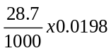 = 0.0005683 mol

(ii) Given that 1 mol of X can react with 2 mol of sodium thiosulfate, calculate the number of moles of arsenic in the sample.
Since X is iodine, I₂, thus

I₂ ≡ 2 S₂O₃²⁻ and 2 AsO₄³⁻ ≡ I₂ => AsO₄³⁻ ≡ S₂O₃²⁻
No. of mol of I₂ = x No. of mol of S₂O₃²⁻ = x ()
= 0.0002841 mol

No. of mol of AsO₄³⁻ = 2 x No. of mol of I₂ = 2 x 0.0002841
= 0.0005682 mol
AsO₄³⁻ ≡ As
So, No. of mol of As = 0.0005682 mol

(iii) Hence, calculate the percentage of arsenic in the sample.
% of As in sample = 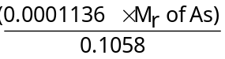 x 100 %
= 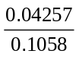 x 100%
= 40.2 %

[5]
[Total: 8]

- (a) Using the diagram below, sketch how S⁺ and S₂⁺ ions will behave in an electric field and state clearly the relative magnitudes of deflection of the two beams.
+
(

[2]
Both S₂⁺ and S⁺ deflected towards negative terminal and S₂⁺ deviates less than S⁺.

+
(
S₂⁺
S⁺
θ
2θ

(b) (i) Draw the dot-and-cross diagrams of SO₂ and SO₃ molecules.
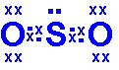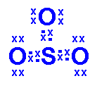

[2]
(ii) With respect to their intermolecular forces, explain why SO₃ has a higher boiling point than SO₂.
Both SO₂ and SO₃ have Van der Waals’ forces.
However, since SO₃ has a larger electron cloud than SO₂,
it has stronger Van der Waals’ forces, and hence, higher boiling point.
…………………………………………………………………………………………………
…………………………………………………………………………………………………
…………………………………………………………………………………………… [2]
(iii) With the use of chemical equations, show the reactions between SO₂ and SO₃ with an alkali.
SO₂ + 2NaOH → Na₂SO₃ + H₂O
SO₃ + 2NaOH → Na₂SO₄ + H₂O
…………………………………………………………………………………………………
…………………………………………………………………………………………… [2]
(c) Sulfur and chlorine can react together to form disulfur dichloride, S₂Cl₂. When 1.00 g of S₂Cl₂ was reacted with water, 0.36 g of sulfur, S was formed, together with a solution containing a mixture of sulfurous acid, H₂SO₃, and hydrochloric acid, HCl.
- Calculate the mole ratio between S₂Cl₂ and S in the above reaction.
amount of S₂Cl₂ = 1.00/135.2 = 0.007396 mol
amount of S = 0.36/32.1 = 0.01121 mol
mole ratio = 0.007396 : 0.01121
= 1 x 2 : 1.5 x 2
= 2 : 3
[3]
- Hence, deduce the equation for the reaction between S₂Cl₂ and water.
2S₂Cl₂ + 3H₂O → 3S + H₂SO₃ + 4HCl
……………………………………………………………………………………………...[1]

[Total: 12]

- In June 2009, the World Health Organization (WHO) has declared the new strain of flu virus, H1N1 as a pandemic. This strain is known as “swine flu” as it has its origin from the swine. This novel virus spread worldwide and had caused about 17,000 deaths by the start of 2010.
To reduce the extent of spread of this virus, one of the common drugs that has been used to prevent or treat flu is Oseltamivir or better known as Tamiflu.
The starting reagent to synthesise Tamiflu is shikimic acid, which is extracted from star anise, the seed pod of an evergreen tree.

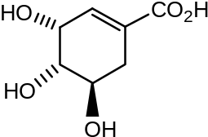
Shikimic acid

Shikimic acid molecule can exhibit geometric isomerism. A large amount of star anise has to be used before enough shikimic acid is obtained to synthesize Tamiflu.

(a) (i) Explain what is Geometric isomerism.
Geometric isomerism is a form of stereoisomerism where the isomers have restricted bond rotation and contains two different groups on the C of the restriction.
…………………………………………………………………………………………………
……… ………………………………………………………………………………………...
(ii) Explain why shikimic acid molecule can exhibit geometric isomerism.
The hydroxy groups can either be on the same side (cis) or on opposite sides (trans) of the ring.
…………………………………………………………………………………………………
……… …………………………………………………………………………………… [2]
A student suggested the following reaction scheme to synthesize shikimic acid from 5-Chloro cyclohex-3-ene-carboxylic acid, 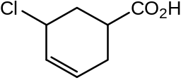.
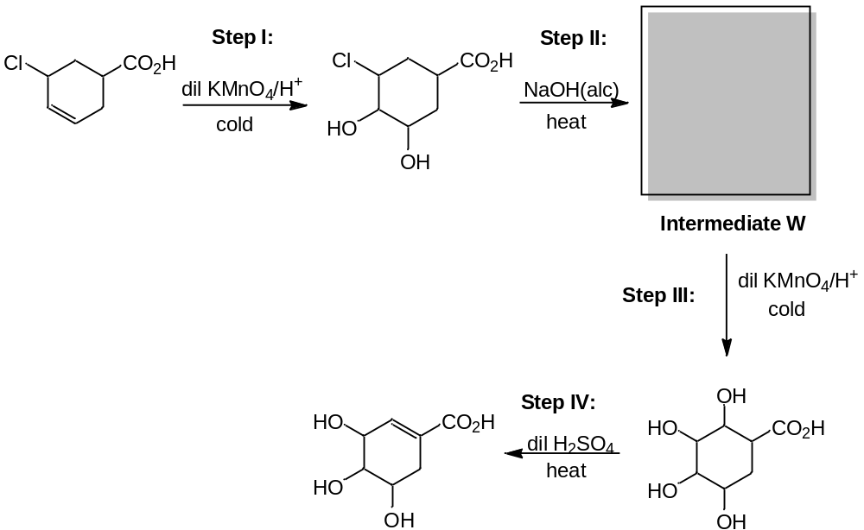
(b) State the types of reaction in steps I, II and IV by filling in the table below.
Step | Type of reaction
I | Oxidation/oxidative addition
II | Elimination/ Dehydrohalogenation
IV | Dehydration/ Elimination of H₂O
[3]

(c) Suggest two possible structures of intermediate W and state, with brief explanation, which structure fits the description of the reaction scheme above.
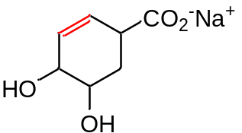 and 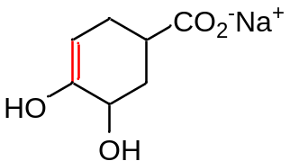

fits in the description as the C=C double bond must be at the position shown so that it can undergo mild oxidation with acidified KMnO₄ to form the diol as shown on the reaction scheme.

[3]
(d) There is a mistake to one of the steps of the reaction scheme that the student suggested. Identify the wrong step and suggest how it can be modify.
[Hint: Could either be wrong reagents or conditions used.]
Step IV is wrong as dilute H₂SO₄ cannot be used as a dehydrating agent to form Shikimic acid.

Concentrated H₂SO₄ should be used instead.

[2]
[Total: 10]

- The Singapore 2010 Youth Olympic Games or YOG is an international multi-sport event for youths that has taken place, making Singapore the first to host this event in the XXIX Olympiad. The Games consisted of 3,600 athletes between 14 and 18 years of age from 204 National Olympic Committees (NOCs) competing in 184 events in 26 sports.
To ensure that the young athletes can perform to their best ability, designing appropriate training for them becomes very important. This will help them build strong foundation so as to enable them to perform to their best during such competitions.
During a normal training, when an athlete’s body receives enough oxygen, most cells in the body will burn glucose in a two-step process to form water and carbon dioxide. Glucose is first broken down to pyruvate (salt of pyruvic acid) which will then undergo oxidation in the presence of oxygen to form water and carbon dioxide.
Step 1:
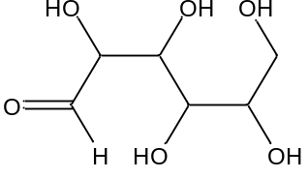  Glucose |  | 2 | 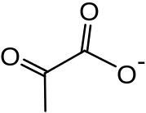  Pyruvate

Step 2:
4 | Pyruvate | + 5 O₂ |  | 8 CO₂ + 6 H₂O

However, when training becomes more intense, the body will receive inadequate supply of oxygen. As such, the excess pyruvate produced from the first step will in turn be converted into lactate (salt of lactic acid), which allows glucose to break down to produce energy. To maintain electroneutrality, equal amount of protons will also be released to the blood. In the presence of an enzyme, lactate dehydrogenase, it helps to catalyse the conversion at high rates. This will result in large amounts of lactate to accumulate in the blood and in turn allows more protons to be released causing the pH to drop. (Note: If a youth athlete weighs 50 kg, then approximately 49 % of his body weight is made up of blood.)

The normal pH of blood plasma is approximately 7.4. If it falls below 7.35, a state of acidosis will exists. At this stage, athletes will show symptoms of shortness of breath, increased heart rate, and muscles soreness. This will affect the performance of the athletes.

(a) (i) Define what is pH.
pH is a measure of the acidity or basicity of a solution. It is equal to p[H], the negative logarithm (base 10) of the molar concentration of dissolved hydronium ions (H₃O⁺) or hydrogen (H⁺) ions.
(Accept pH = -lg [H⁺])
………………………………………………………………………………………………… …………………………………………………………………………………………………
(ii) Calculate the volume of blood in a 50 kg young athlete, assuming that the volume of blood is equal to the mass of blood. (1 kg = 1000 cm³)
Vol. of blood = Mass of blood = 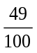 x 50 x 10³ g = 24.5 x 10³ cm³
= 24.5 dm³

(iii) Calculate the excess amount of protons in the blood to cause the soreness of muscles to occur. Given that lactic acid is a monobasic acid, hence state the amount of lactate that has accumulated.
Since pH = -log[H⁺] => [H⁺] = 10^{-pH}

Amt of excess proton = Amt of proton at pH 7.35 – Amt of proton at pH 7.4
= (10^{-7.35} x 24.5) – (10^{-7.35} x 24.5)
= (4.467 x 10⁻⁸ x 24.5) – (3.981 x 10⁻⁸ x 24.5)
= (1.094 x 10⁻⁶) – (9.754 x 10⁻⁷)
= 1.186 x 10⁻⁶ mol

Thus, amt of lactate = 1.186 x 10⁻⁶ mol

[5]

(b) (i) If an athlete took in 2500 cm³ of oxygen during a normal workout and only 16 % of the oxygen was used up, calculate the amount of CO₂ produced in the blood, assuming that it is at room temperature and pressure.
Amt of O₂ taken in = 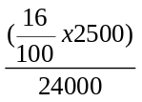 = 0.01667 mol
5 O₂ ≡ 8 CO₂
Amt of CO₂ produced = x 0.01667 = 0.0267 mol

(ii) As CO₂ is produced, it will dissolve in water present in the blood to form a buffer mixture made up of carbonic acid with bicarbonate salt, H₂CO₃/HCO₃⁻.

Explain, with the help of appropriate equations, how this buffer works to maintain constant pH in blood under normal conditions.
H₂CO₃ ⇌ HCO₃⁻ + H⁺

In the presence of small excess H⁺,
H⁺ + HCO₃⁻ → H₂O + CO₂
The excess H⁺ is removed through formation of H₂O and CO₂.

In the presence of small excess OH⁻,
OH⁻ + HCO₃⁻ → H₂O + CO₃²⁻
The excess OH⁻ is removed through formation of H₂O and CO₃²⁻.

[5]

[Total: 10]

Section B
Answer two of the three questions in this section on separate answer paper.

5. Retinol is one of the animal forms of Vitamin A. It is a fat-soluble (or water-insoluble) vitamin and can be used to treat many conditions, especially skin conditions such as acne and wrinkles.
Retinol is produced in the body from the hydrolysis of retinyl esters such as retinyl ethanoate (C₂₂H₃₂O₂) and from the reduction of retinal. It can also be obtained through consumption of animal produce such as liver and eggs or vegetables such as carrots and spinach.
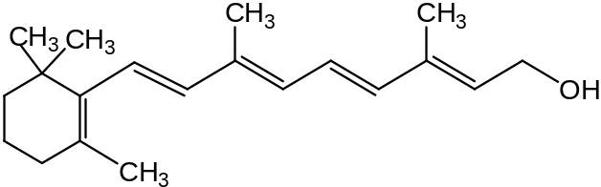
Retinol
(a) With reference to the structure of the molecule, suggest a reason why retinol is insoluble in water. [1]
Though contains hydroxyl group (-OH), but is predominantly made up of non-polar hydrocarbon chain. Thus, it is insoluble in water.

(b) (i) Explain why for the synthetic reaction to form retinol from retinyl ethanoate (ester of retinol), alkaline hydrolysis was preferred to acidic hydrolysis.
Hence draw the organic products that were produced from the alkaline hydrolysis, with the aid of the simplified diagram provided below.
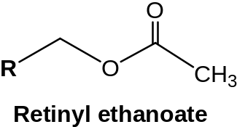
Alkaline hydrolysis can enable complete conversion of the ester to its acid and alcohol constituents.

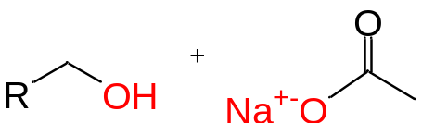

- The graph below shows the variation of the concentration of retinyl ethanoate in the hydrolysis reaction with time.
Using the graph below, deduce the order of reaction with respect to retinyl ethanoate. 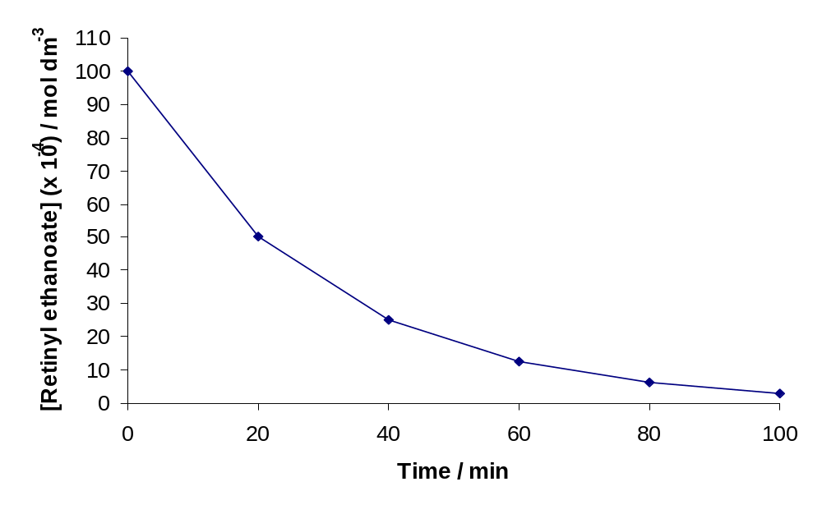
Constant half-life = 20 min, thus order of reaction wrt retinyl ethanoate is 1st order.
[NaOH] = 0.1 mol dm⁻³
Initial rate = 0.4 mol dm⁻³ min⁻¹

(iii) When the concentration of sodium hydroxide, NaOH is doubled, the rate of reaction for this reaction is also doubled.
State the order of reaction with respect to NaOH and hence write down the rate equation of the reaction.
When NaOH is doubled, rate is doubled, thus order of reaction wrt NaOH is 1st order.

Rate = k[Retinyl ethanoate][NaOH]

(iv) Calculate the value of the rate constant, k, of the reaction.
[8]
Rate = k[Retinyl ethanoate][NaOH]
- k = 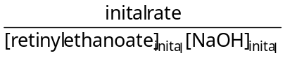
- k = 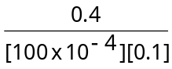
k = 400 mol⁻¹ dm³ min⁻¹

(c) Pure retinol is very sensitive to oxidation. Thus, when retinol is prepared synthetically as a dietary supplement, it has to be stabilized by forming into its ester derivatives.
25.0 cm³ of 0.1 mol dm⁻³ of retinol is added to 50.0 cm³ of ethanoic acid of equal concentration to react in a reversible reaction to form retinyl ethanoate (C₂₂H₃₂O₂).
conc. H₂SO₄

heat

Retinol(l) | + CH₃CO₂H(l) |  | Retinyl ethanoate(l) (C₂₂H₃₂O₂) | + H₂O(l)

(i) State the Le Chatelier’s Principle.
If a chemical system at equilibrium experiences a change, then the equilibrium shifts to counteract the imposed change and a new equilibrium is established.

(ii) Given that the equilibrium constant of the backward reaction, K_{d} is 5.2. Calculate the value of equilibrium constant, K_{f} of the forward reaction.
K_{f} = 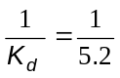 = 0.192

(iii) Calculate the initial amounts of retinol and ethanoic acid.
Initial [retinol] = 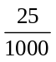 x 0.1 = 0.00250 mol
Initial [ethanoic acid] = 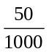 x 0.1 = 0.0500 mol

(iv) Hence calculate the percentage conversion of retinol when equilibrium is attained.
[7]
Retinol + Ethanoic acid ⇌ retinyl ester + H₂O
Initial/mol 0.0025 0.005 0 0
Change/mol -x -x +x +x
Eqm/mol 0.0025 – x 0.005 – x x x

K_{f} = 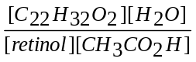 = 0.192
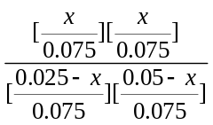 = 0.192
X = 1.68 x 10⁻³ mol

% conversion of retinol = 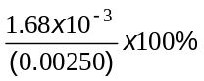 = 67.2 %

(d) The presence of concentrated sulfuric acid, H₂SO₄ can help to hasten the rate of reaction and to increase the yield of the ester.
Explain how the concentrated sulfuric acid, H₂SO₄ can help to increase:
(i) Yield of products
Conc H₂SO₄ is a dehydrating agent and it will help remove H₂O from the RHS of eqm.
By LCP, eqm position will shift to the right to increase the H₂O.
In the process, ester is also produced. So, yield increased.

(ii) Rate of reaction.
Conc. H₂SO₄ acts as a catalyst where it provides alternative reaction path with lower activation energy, E_{a}.
More molecules have energy to overcome the E_{a} and rate increased.

[4]
[Total: 20]

6. (a) Pure anhydrous nitric acid, HNO₃ is a colorless liquid which solidifies at −42 °C to form white crystals and boils at 83 °C.
(i) Given that the H atom is bonded to one of the O atoms, draw the structural formula of HNO₃ and state the type(s) of bonding it contains.
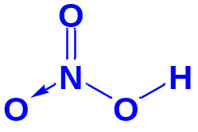
:

(iii) With reference to the structure of HNO₃, suggest a reason why it acts as a strong acid in water. [4]
This is because the O-H bond is very polarized [1] due to the presence of electronegative O atoms.

(b) In an experiment, 100 cm³ of a 0.500 mol dm⁻³ of dilute nitric acid was placed in a plastic beaker.
100 cm³ of 0.500 mol dm⁻³ sodium hydroxide was then added and the mixture stirred.
Both solutions were initially at the same temperature. After mixing, the temperature of the mixture was found to have risen by 3.2 ºC.
(i) Define the standard enthalpy of neutralisation with respect to the above reaction.
The standard enthalpy change of neutralisation is the enthalpy change when 1 mole of water is formed between the reaction of dilute nitric acid and aqueous sodium hydroxide at 298 K and 1 atm.

(ii) Using the given information and relevant data in the Data Booklet, calculate the enthalpy change of neutralisation.
HNO₃ + NaOH → NaNO₃ + H₂O
number of moles of water formed = 100/1000 x 0.500 = 0.0500 mol

Q = mcΔT = (100+100)(4.18)(3.2) = 2675.2 J

ΔH = - (2675.2/0.05) = - 53.5 kJ mol⁻¹

(iii) The standard enthalpy change of neutralisation of this reaction should be -57.2 kJ mol⁻¹. Suggest an explanation for the difference between this and the value you have calculated in (ii).
The calculated value is lower than the theoretical value because of heat loss to the surroundings.

(c) The salt formed in (b) is an ionic compound.
How would you expect, giving your reasoning, the lattice energy of the salt formed inthe above reaction to differ from that of sodium chloride? [8]

The LE of NaCl is more exothermic or larger in numerical value than NaNO₃.

The ionic charges are the same, but the ionic radius of NO₃⁻ is larger than Cl⁻.

(d) Toluene is a clear water-insoluble liquid with the typical smell of paint thinners. It is widely used as an industrial feedstock and as a solvent. Similar to other solvents, toluene is sometimes also used as an inhalant drug for its intoxicating properties; however, this can potentially cause severe neurological harm.
Toluene has the following structure.
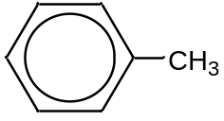

Compound Z can be synthesized from toluene. Outline the three-step synthesis of the Z from the intermediate I, indicating clearly the reagents and conditions, and intermediates.

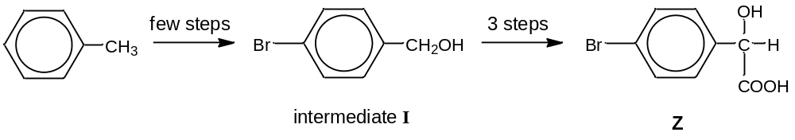
[5]

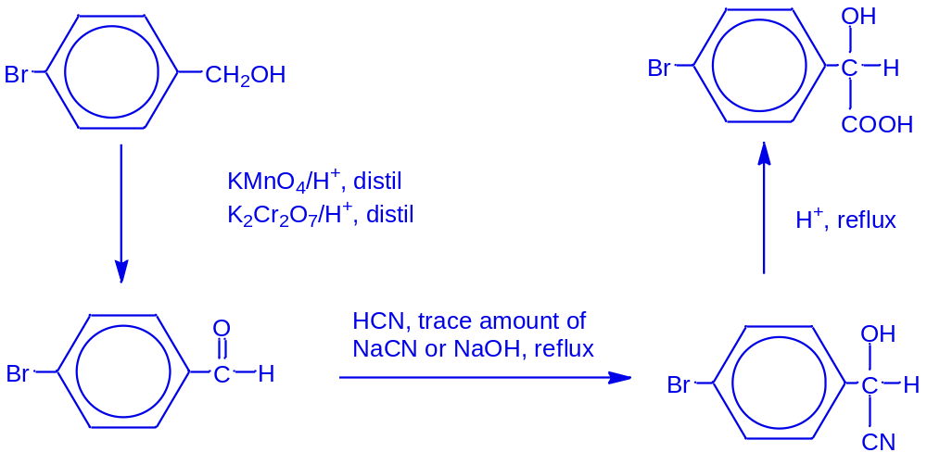

(d) Suggest a chemical test which can be used to distinguish between the following two compounds. In your answer, include the reagents and conditions used, and any observations made.
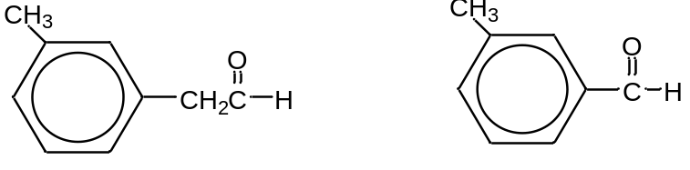
[3]
Chemical Test:
Add Cu²⁺ ions in alkaline medium to both compounds, and heat
Observations:
A reddish brown precipitate is formed for the aliphatic aldehyde.
No reddish brown precipitate is formed for benzaldehyde.

[Total: 20]

(a) An organic compound A with molecular formula C₃H₆O, gives a orange precipitate with 2,4- dinitrophenylhydrazine, but gives no precipitate when warmed with Tollens’ reagent.
A is then reacted with dilute HCN in the presence of trace amount of NaCN, followed by refluxing with excess dilute H₂SO₄ to form an organic liquid B. Liquid B turns moist blue litmus paper red.
Upon prolonged hydrolysis of B, a sweet-smelling liquid C, with molecular formula C₈H₁₄O₅, is formed.
Use all of the above information to identify the organic compounds A, B and C, and draw a structural formula for each of them, showing clearly all the deductions that you make from the information that have been given. Include equations for the reactions that have occurred. [10]
A is likely to be a carbonyl compound since it gives an orange precipitate with 2,4-dinitrophenylhydrazine.
A is a ketone since it gives a negative test with Tollens’ Reagent.
Hence, the likely structure of A is
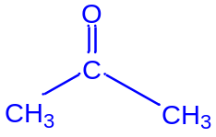
Hence, the reaction of A with 2,4-dinitrophenylhydrazine is
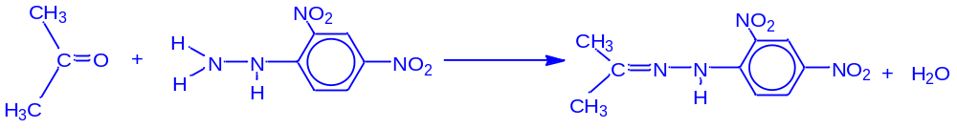
When A is reacted with dilute HCN in the presence of trace amount of NaCN, a cyanohydrin is first formed.
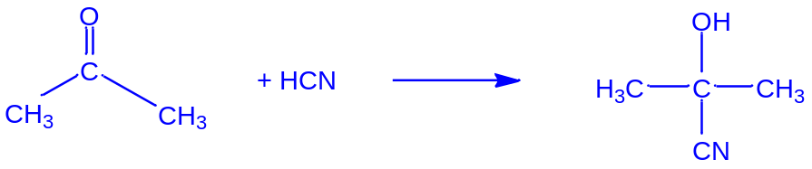

Upon hydrolysis with dilute sulfuric acid, the nitrile group is converted into a carboxylic acid which turns moist blue litmus red.
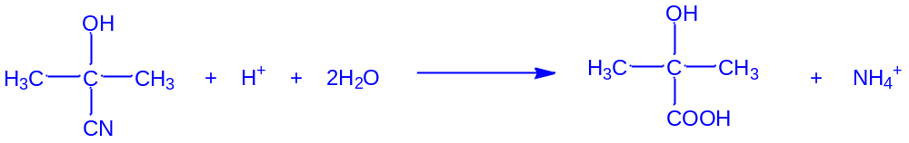

B
Upon prolonged hydrolysis, esterification takes place.
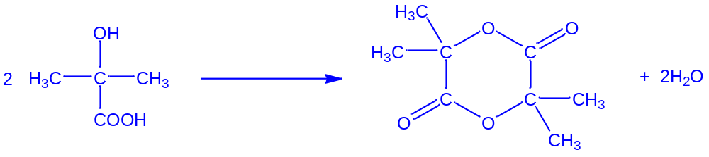
C

(b) Some physical properties of the oxides of elements D, E, F and G are given below.
Formula of oxide | Melting point/ ºC | Appearance at room temperature and pressure | Conductivity in molten state
DO₂ | 1700 | White solid | None
E₂O | 0 | Colourless liquid | None
FO | 2850 | White solid | Good
GO₂ | -73 | Colourless gas | None

Describe the types of structures and all the bonds in the above four oxides.
 | DO₂ | E₂O | FO | GO₂
Structure | giant covalent | simple molecular | giant ionic | simple covalent
Type(s) of bonding and forces | covalent bonding | intramolecular: covalent bonding  intermolecular: hydrogen bonding | ionic bonding | intramolecular: covalent bonding  intermolecular:  van der Waal’s forces or permanent dipole-permanent dipole interactions
[10]
[Total: 20]

- BLANK PAGE -

